Hi Friends,

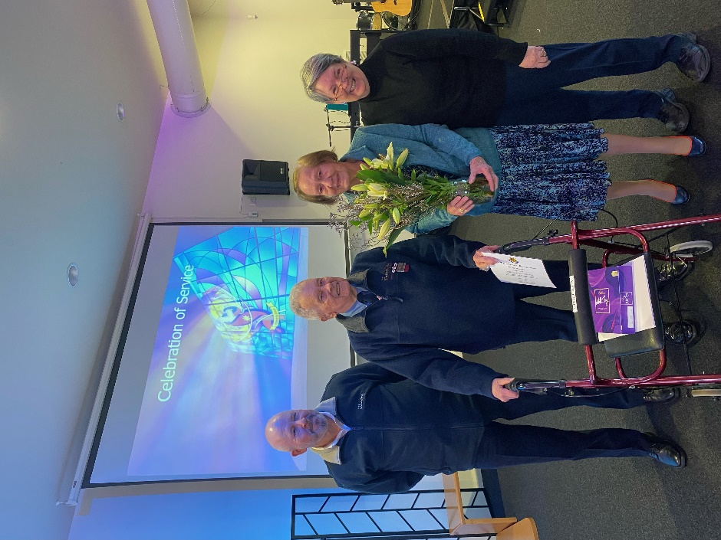

Last Sunday was a wonderful time celebrating Alex (and Ruth). We give thanks for Alex's faithfulness in his ministry over 80+ years.

This Sunday will include another special moment as we give thanks and celebrate as Robert and Leotrina (with Louis and Kenan) bring Romeyn (who turns 1 this week) to be dedicated. It has been wonderful to have their family worshipping with us over the past few months.

Tomorrow (Saturday 27th) Every Nation Church who use our building every Saturday morning for worship celebrate their 8th Anniversary. We pray God's blessing in Pastor Joe and the team and wish them a Happy 8th Anniversary.

For the Youth:

Here are the dates for term 3 combined Canberra Salvo Youth Group 7pm Friday nights fortnightly (high School-21)

School Week 2 - Tuggeranong - Olympics theme night (2nd August) bus leaves hall at 620pm

School Week 4 - Woden - switch and board games (16th August) bus leave halls at 620pm

School Week 6 - Gungahlin - movie night & dessert (30th August)

School Week 8 - IKEA scavenger hunt - activity TBC (13th September ) bus leaves hall at 620pm

School Week 10 - Woden - myth busters night (27th September) bus leaves hall at 620pm

God Bless You